**Task 8: Dashboard of Vrinda Store**

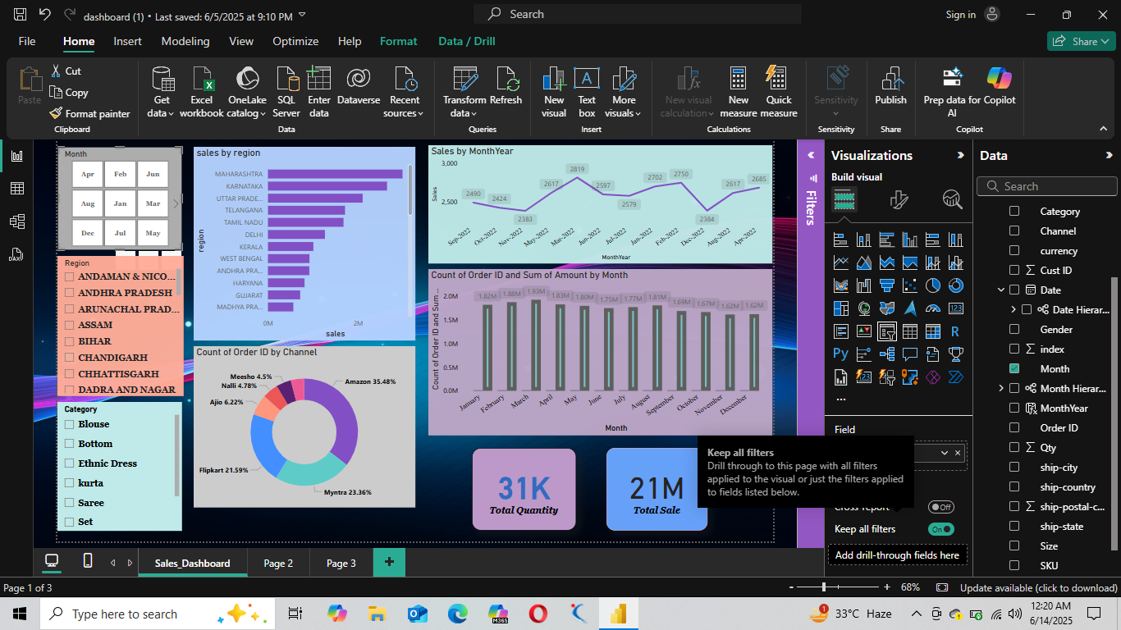

**Key Insights**

**1. Maharashtra Leads in Sales by Region**

* **Insight**: Maharashtra is the top-performing region in terms of total sales, followed by Karnataka and Uttar Pradesh.
* **Actionable Takeaway**: Focus marketing and inventory efforts on these top regions to sustain growth and explore replicating their success strategies in lower-performing states.

**2. Amazon Dominates as the Sales Channel**

* **Insight**: Amazon accounts for the largest share of order volume at **35.48%**, followed by Myntra (**23.36%**) and Flipkart (**21.59%**).
* **Actionable Takeaway**: Strengthen partnerships and promotional activities on Amazon while evaluating performance optimization for other channels.

**3. Sales Show a Seasonal Trend**

* **Insight**: Sales tend to **peak in March and April**, with noticeable dips around **October and December** based on the line and bar charts.
* **Actionable Takeaway**: Plan product launches and campaigns ahead of March-April peaks; investigate reasons for October-December declines (e.g., stockouts, seasonal preferences).